HEWELL BOWLING CLUB – ONLINE RINK DIARY
The only way to book a rink is through the rink booking system. We are required to keep a record and if you haven’t booked a rink on the system, you must not play. If you are unable to use the system please approach another member who is conversant with the system and ask them if they will book rinks for you – I will not have the time to take telephone bookings this season I’m afraid. You must not turn up to play unless you have a booking on the system – this is a requirement in order to show that we are managing numbers.
The online rink booking diary is easy to use provided you follow the instructions. If you used it last season, the username is typically your first name plus the first letter of your last name – so for me paulh. The exception will be if you tried several times to register last year – then your username will be followed by a ‘1’ or even a 2 or 3 depending how many times your registration failed. When you were set up the password was ‘hewell’ but you may have changed it. If you can’t remember your password just click on the ‘forgotten password’ button.
If you are using the system for the first time then you will need to register. That will generate an email to me to authorise and once I’ve done that you will be able to book rinks. Detailed instructions follow but a couple of things for everyone to note.
- All our ‘organised bowling’ (internal and external leagues, weekend club comps, club afternoons etc.) is already booked on the system – there is no need for you to book this.
- When you book a rink you are simply booking a session, not the rink number. The system automatically allocates the next rink number. Please do not try to clever by booking say 4 rinks and then cancelling 3 so you get rink 4 for example – every cancellation generates an email to me and I don’t want my email box clogged up! You just turn up and play on any vacant rink. The only current exceptions are Thursday @ 12:00 when rinks 1 and 2 are reserved for internal leagues and Friday @ 16:00 when the same 2 rinks are reserved for leagues.
- The instructions relate to use of the system using a laptop – if you are using a tablet or telephone it might look slightly different.
When you book a rink it will show as a highlighted session. You can only edit your own bookings.

- To access the website please click on the following link or copy the link to your internet browser
http://hewell.rinkdiary.co.uk/

- This will take you to the home page (see below). It will show you this week’s view and any bookings will simply show as ‘booked’. You need to sign in – Click on ‘sign in’ box at top right (in red box)
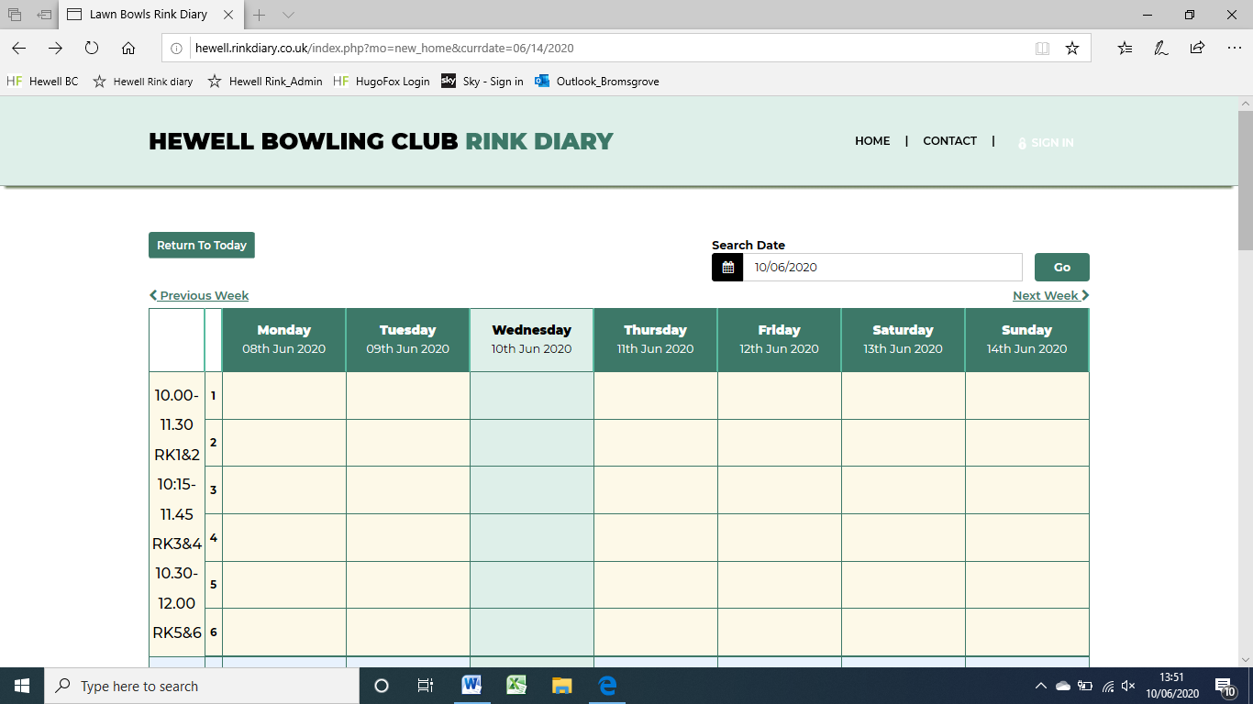

- You should then see the login page (see below). Enter your user name and password – the user name has been emailed to you by Hewell Rink Diary and will usually be your first name plus initial letter of your surname. The first time you sign in the password will be hewell.
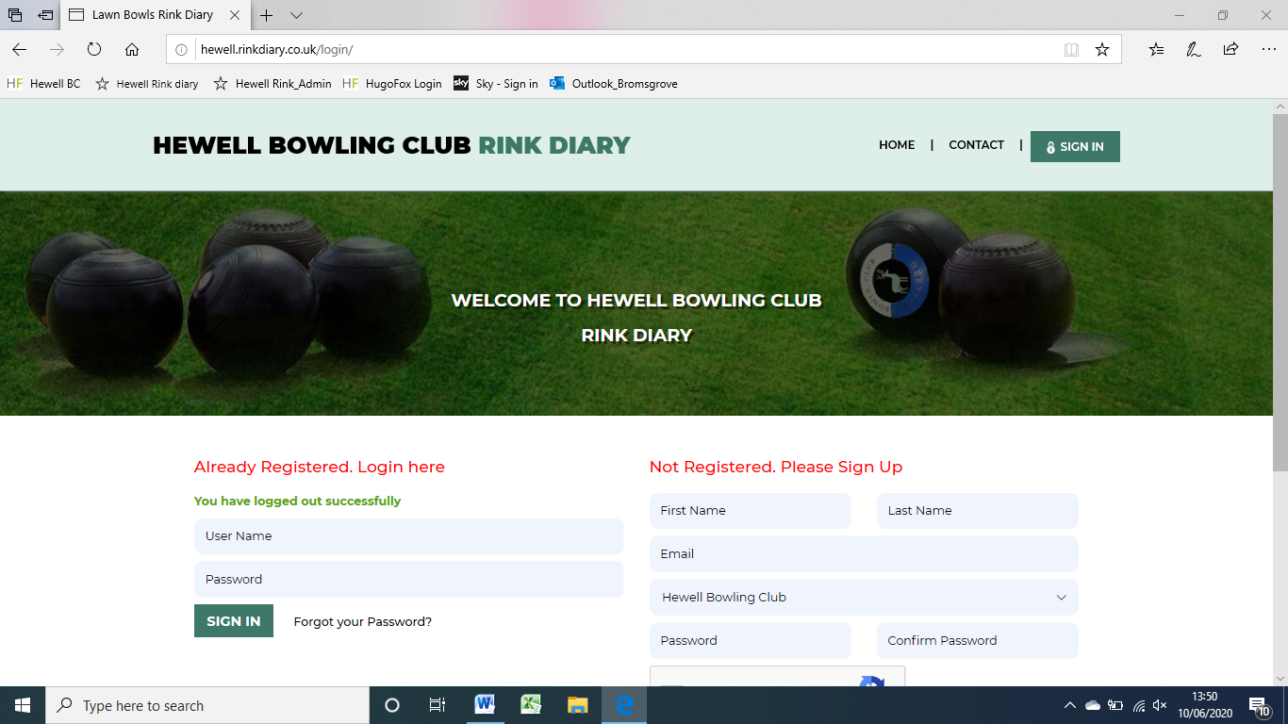

- The first time you sign in you can change your password to something memorable for you. Simply click on ‘my profile’ at the top of the page and enter and save a new password.
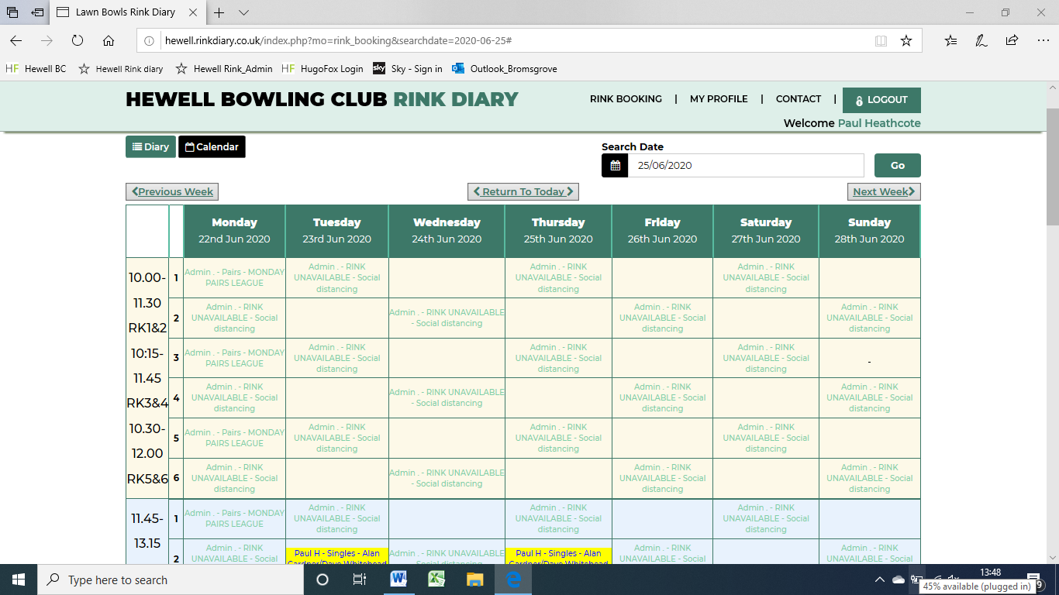

- You are now ready to book a rink. The sessions show down the left hand side and the alert message when you sign in detail the times for each session on each day.
- To book a rink, click on a free box at the day and time you want to play. The ‘book your slot’ box will appear on your screen. It will show the date and the timeslot you have chosen and it will show your name. you must then complete the two drop down boxes and the ’name of opposition’ box.
- The ‘choose slot’ drop down will show the number of rinks available in that timeslot. You are not choosing a rink to book, simply the number of rinks you want to book. You will almost always be selecting ‘1’.
- The ‘Game name’ has a self explanatory drop down list and you choose the most appropriate descriptor.
- Finally you must complete the ‘name of opposition’ box to complete the booking – this can either be the person you are playing against or just ‘ practise’. Then click ‘request slot’
- You will have been allocated a rink within that timeslot – it will always be the first free rink so for the time being the earliest time in that particular slot.
- It deliberately doesn’t allow you to select the rink you wish to play on as typically players draw rinks on the day or the team captain selects rinks for a match on the day.
- If you wish to delete a booking click on your booked slot and a ‘booked slot details’ box will appear similar to the ‘book your slot’ box. Simply click ‘delete slot’.
- Finally the system allows you to provisionally book rinks – maybe when you are looking to arrange club competitions. Tick the provisional booking slot and if you don’t confirm the booking it will auto cancel after 24 hours.
